**Lesson03 Publish Web App into VM service**

**Notes: -**

# 

**1-on the Azure portal > click on the DNS name**

**(We select the IP address static and we type the DNS name as enbeh.com)**

**(We see that DNS Name = enbeh.westeurope.cloudapp.azure.com)**

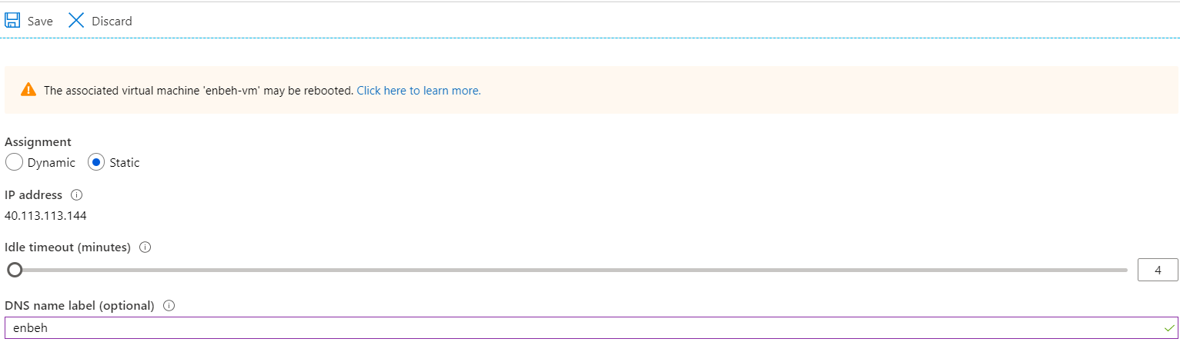

**2-on the Azure portal > click on Connect**

**We see the DNS name we passed it will connect with username and password**

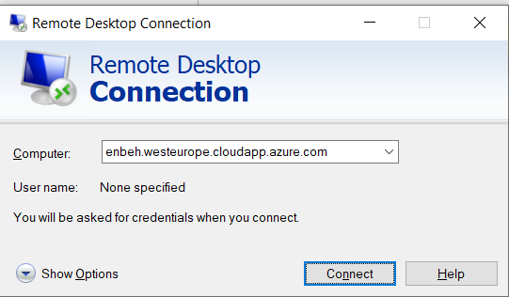

<https://www.microsoft.com/en-ca/download/details.aspx?id=43717>

**3-on Azure VM 🡪 server manager 🡪 Manage 🡪 add roles and features**

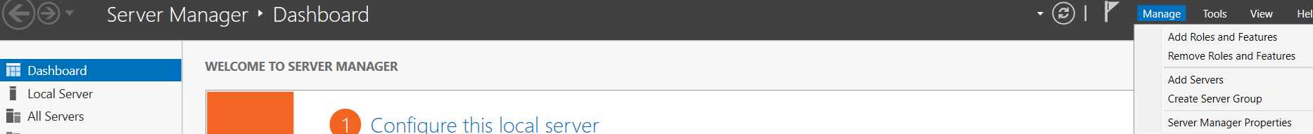

**4-we have to select on IIS option with select .Net framework 3.5 and 4.7 features plus add the IIS Management service**

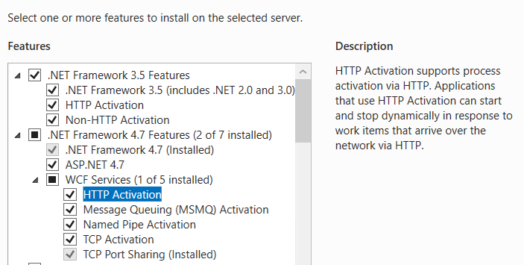

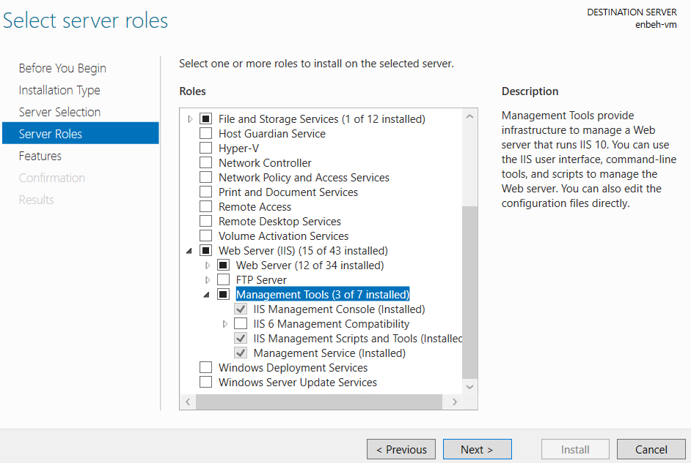

**5-on the below link we download and install Microsoft Web Deploy 3.6 to apply VM IIS to hosting web application within IIS**

**6-on server management > local server > make IE enhanced security configuration (OFF)**

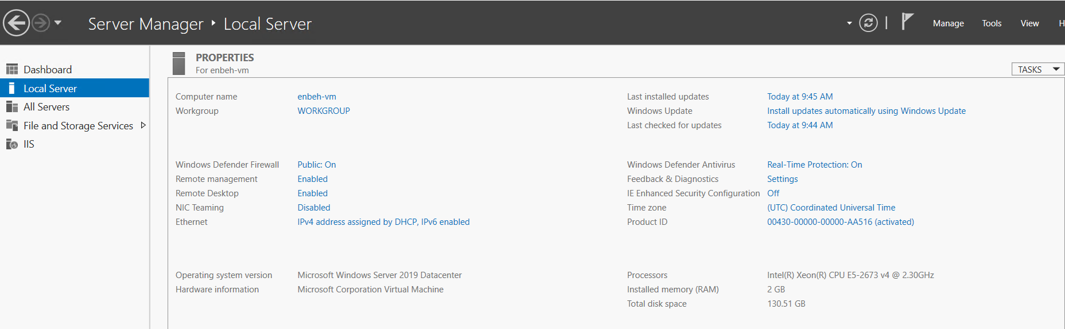

**7-on Azure VM 🡪 Network 🡪we add new bound for firewall azure VM**

**(We add two network roles one for access the server through http port 80 and another for access to IIS management service 8172)**

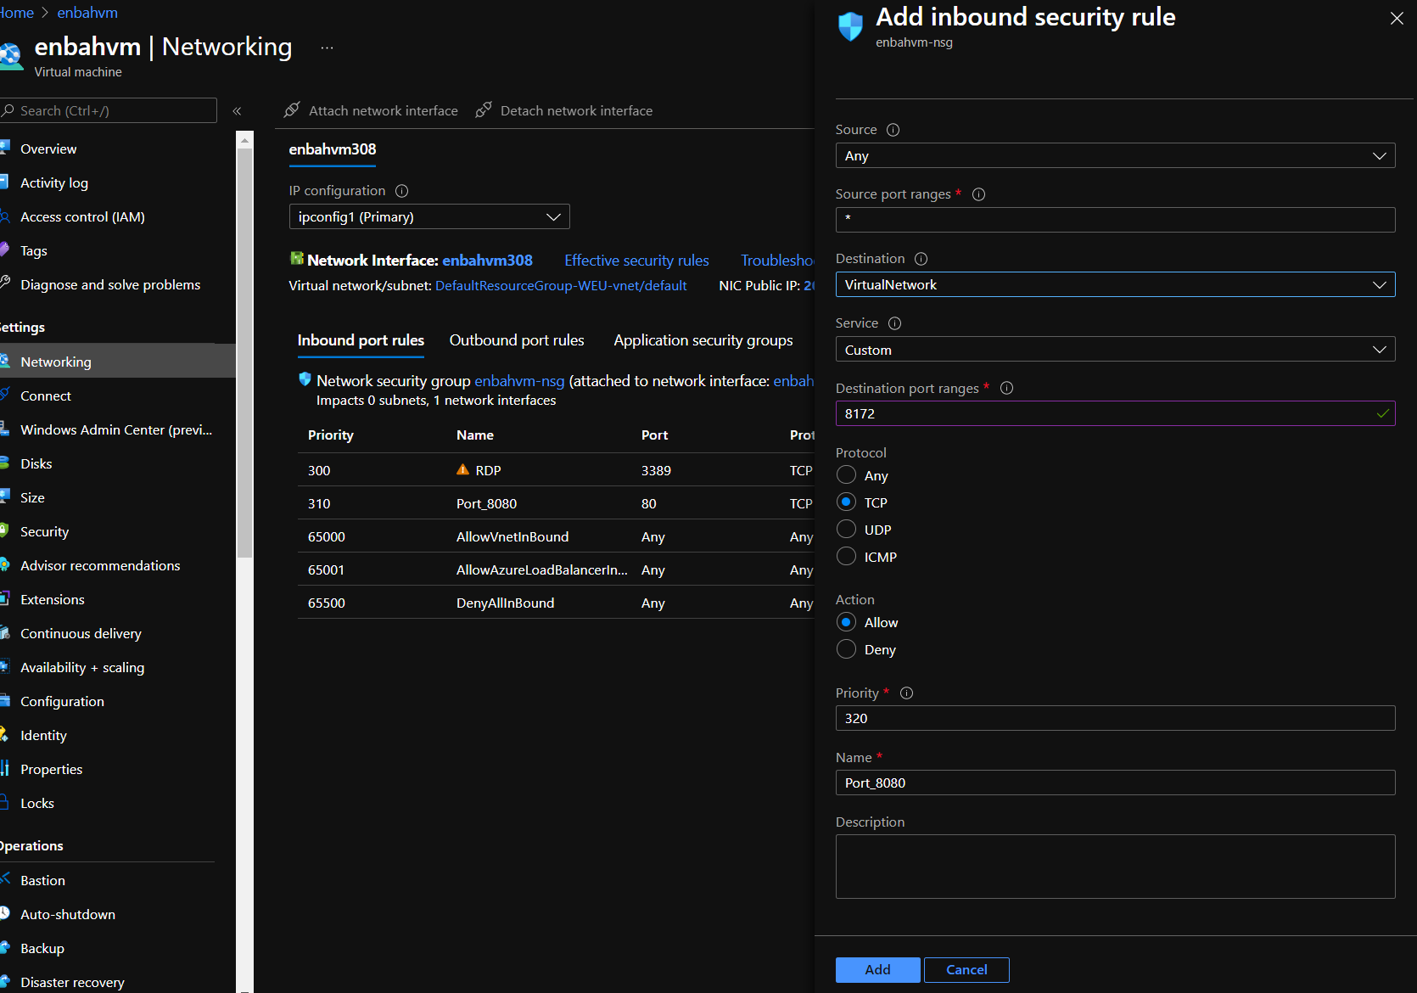

**8-we add another Inbound Role with set Destination allow on Port 80**

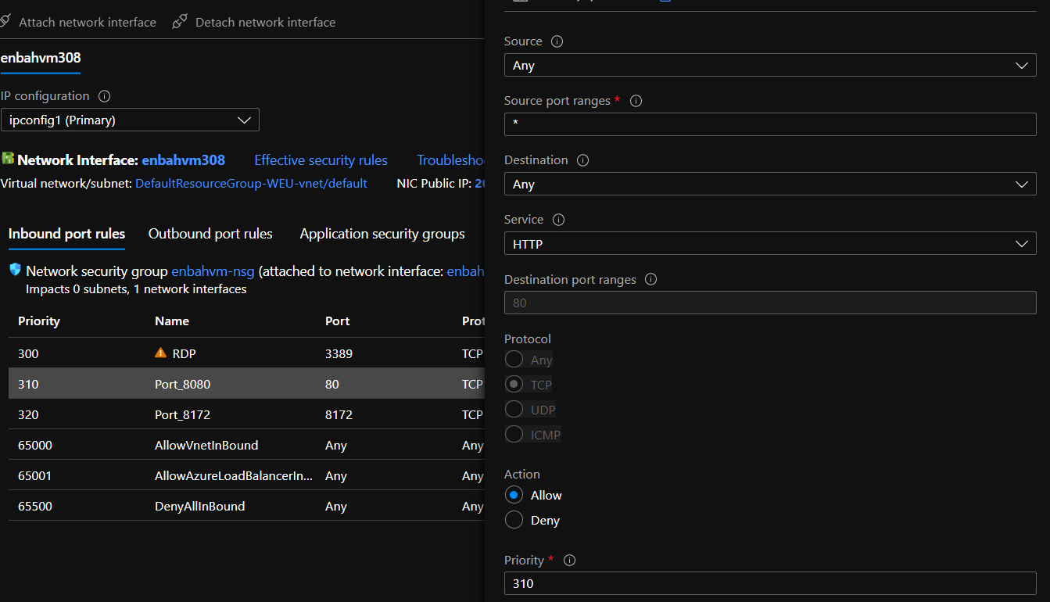

**9-we will download and install VS 2019 with install Azure Development as below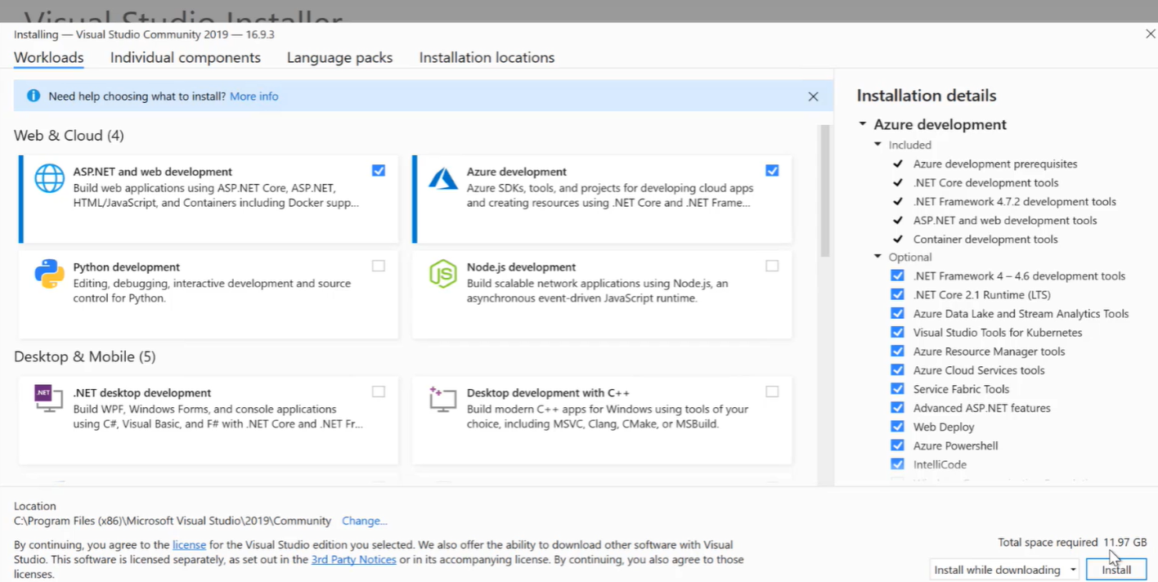 10-on the Azure VM install asp.net core runtime 3.1 and web deploy   
  
  
  
  
  
  
  
  
  
  
9-on VS project 🡪 right click 🡪 publish**

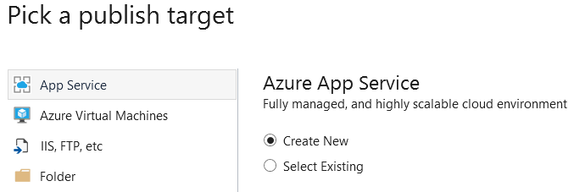

**10-we select the azure subscription and resource group and Hosting plan and application insight and we select the VM**

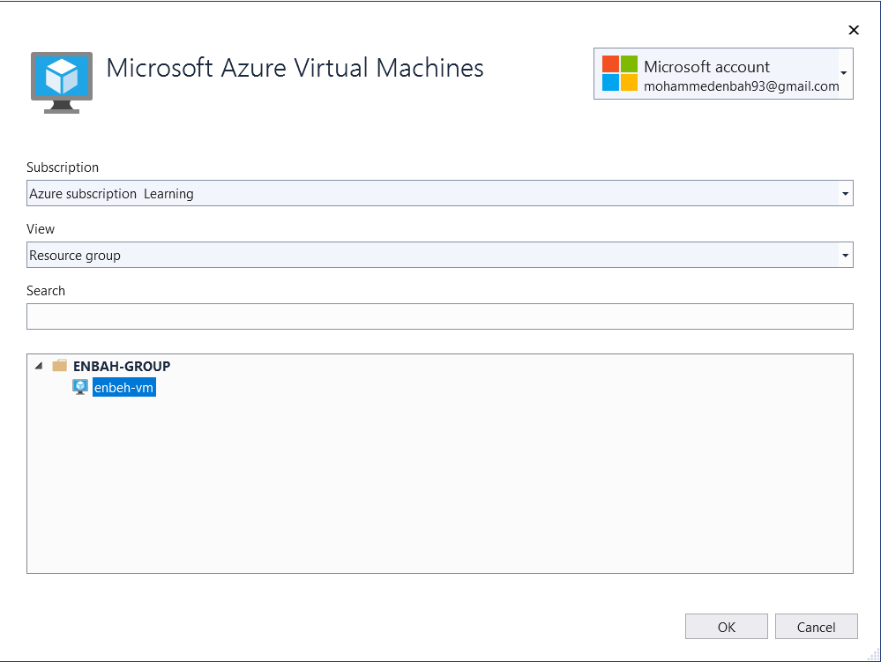

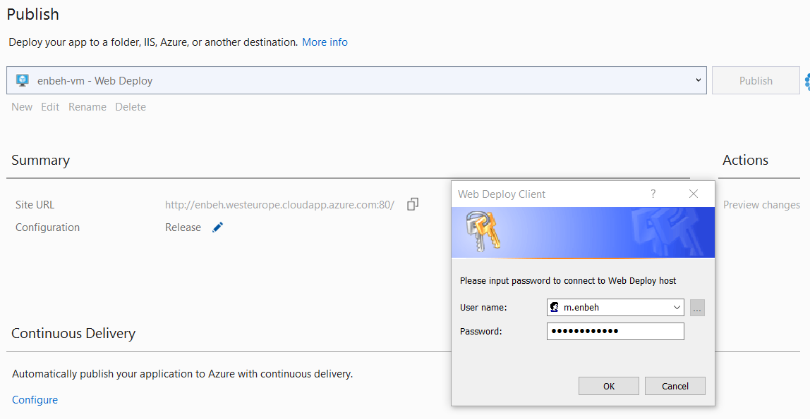

**(on the chrome URL we** [**http://enbeh.westeurope.cloudapp.azure.com/Home/Contact**](http://enbeh.westeurope.cloudapp.azure.com/Home/Contact)**)**

**10-we have to know that to make sure that we have to install IIS Management service before install Microsoft Web Deploy 3.5 to apply upload to IIS.**